

__________________________________________________________

**RHODES UNIVERSITY SUSTAINABLE LAND MANAGEMENT FOR RURAL RESILIENCE PROJECT (RU-SLMRR), GEF5**

**QUARTERLY PROGRESS REPORT**

______________________________________________________________

**Report compiled by**: Dugal Harris

**Organization**:

**Quarter and year**: 012018

**Reporting outputs**: 3.1b

**Date of report:** 20062018

__________________________________________________________________________________

# INSTRUCTIONS

# Please refer to Sections A-E below and include the necessary information and attachments to document your progress toward one or more outputs of the GEF5 SLMRR Project (use the examples provided to guide you).

# Please submit your completed progress report on or before the 12th day of the final month of a particular quarter. This is according to reporting regulations set by Department of Environmental Affairs for the GEF5 SLM Project.

# Please submit your report to: Rebecca Powell (rebeccajoub@gmail.com) and cc James Gambiza (j.gambiza@ru.ac.za).

# SECTION A: OUTPUTS PROGRESS & CHALLENGES (Please complete columns A-F in the table below)

**\***Progress toward achieving planned activities indicated in column C.

**\*\*** Challenges to achieving progress on activities, as identified in columns C and D

| AOutput code | BYR1 goals (deliverables) | CPlanned activities for reporting quarter | DProgress*1 = completed, no concerns; 0.5 = partial progress, some concerns; 0 = no progress, major concerns | EChallenges** | FAddressing challenges |
| --- | --- | --- | --- | --- | --- |
| 3.1b | Report on the development of a new carbon methodology for Spekboomveld rehabilitation projects and applicability to these kinds of projects | 1) Apply differential correction to field DGPS data acquired during Q1. 2) Process Q1 field allometric data to produce above ground carbon stock (CS) estimates. 3) Perform preliminary regression analysis on data acquired to date.  4) Update radiometric calibration software to allow for different models and window sizes.  5) Conduct experiments to establish best radiometric calibration model and window size. | 1) 12) 0.53) 14) 15) 16) 1 | 2) Allometric models do not exist for all species. Litter measurements are not yet available.3) Data is limited to 33 plots that have been acquired to date. Imagery is restricted to NGI aerials until a satellite image has been acquired.5) Precise surface reflectance ground truth for measuring accuracy is not available. | 2) Where possible, species without models were grouped into guilds with known species. For some species there were no obvious guilds. These cases require input from a botanist or possible development of new allometric models (using existing data). Litter measurements will be included when they are available.3) Preliminary results were generated subject to the limitations of the current data.5) A SPOT-5 image was atmospherically corrected and used as an approximate surface reflectance reference. |

# SECTION B: IDENTIFIED RISKS AND SOLUTIONS

# Describe the identified risks to the project outputs

# *Allometric models for are not available for some species.*

# *There have been delays in the completion of the carbon stock field sampling. The majority of the carbon stock mapping work can only be done once the field data is available.*

# Describe possible solutions to identified risks

# *These species will be grouped into guilds with similar known species, or new allometric models can be derived from existing data where necessary.*

# *An adjustment to the 2018 timeline/budget is requested i.e. a 1 day/week decrease in Q3 expenditure and a corresponding increase in Q4 expenditure.*

# SECTION C: SUMMARY OF LESSONS LEARNT DURING THE REPORTING QUARTER

# *Best model and window size parameters were established for the accurate radiometric calibration of aerial/satellite imagery.*

# *The results of a preliminary regression analysis for predicting woody C from image features were encouraging (R2=0.78 and RMSE=8.89 t/ha). While these results should not be considered indicative of final mapping accuracies, they do support the efficacy of the carbon stock mapping and field sampling methods that have been adopted.*

# SECTION D: BUDGET TRACKING

# Please note that you will be required to submit a financial report at the end of 2017 (Before December) detailing your expenditure for the year. This requires that you keep a record of all invoices and receipts relating to project expenditure. The format for the report will be sent closer to the time.

**SECTION E: APPENDICES**

**APPENDIX 1 (activities 1 & 2):**

Figure *1 shows a colour-infrared rendering of calibrated NGI aerial imagery covering the GEF study areas. The “pristine, “moderate” and “severe” degradation classes were used for stratifying the sampling plots. Woody carbon (C) estimates were generated for each plot using field measurements acquired by Cosman Bolus and allometric models built by Marius van der Vyver. Plots sampled to date, coloured according to their woody C estimates, are displayed on the map.*

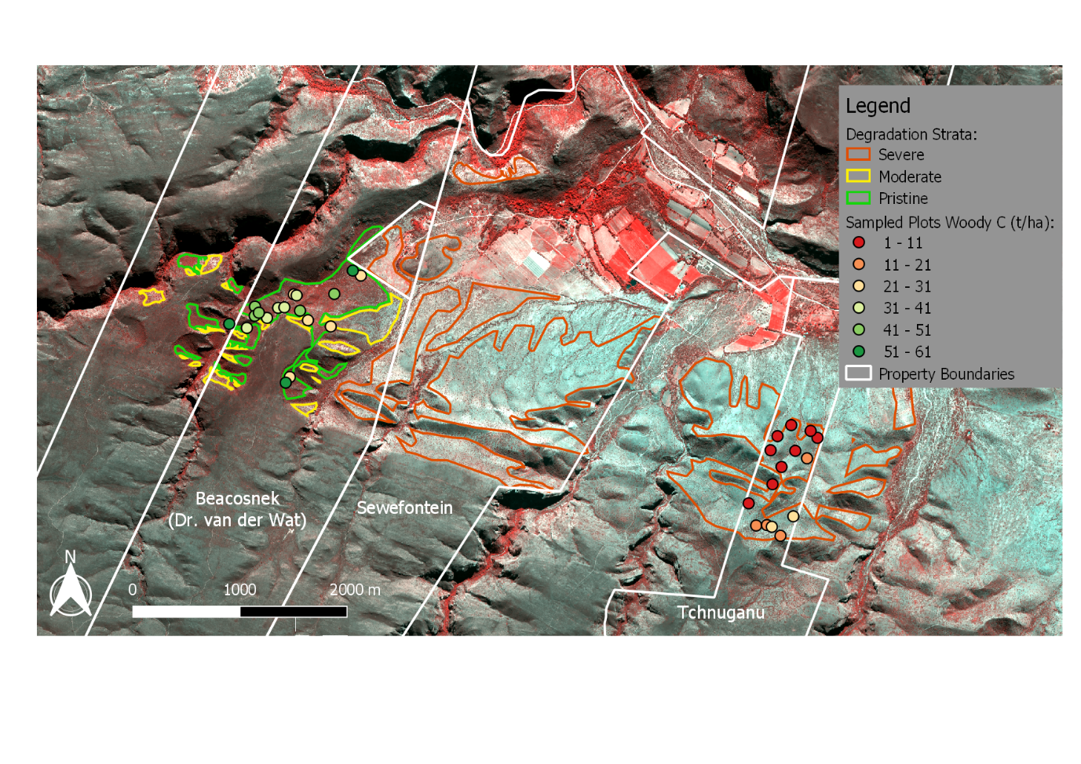

Figure 1 Map of GEF study area with woody C for sampled plots

**APPENDIX 2 (activity 3):**

*A preliminary multivariate regression analysis was conducted to investigate the feasibility of modelling woody C using image features. Data from the 33 completed sampling plots were used for this investigation. Common spectral, textural and vegetation index measures were extracted from calibrated NGI aerial imagery for each sampling plot. A feature library incorporating non-linear functions of these measures was subsequently constructed. Using a mutual information (MI) importance measure, the best individual feature was identified as the normalised red channel ().* Figure *2 shows a reasonably strong correlation between this feature and the woody C estimates. The best combination of features for a multivariate linear model was determined using the LASSO feature selection method. Details of the four chosen features are given in Table 1.*

*A multivariate linear model was constructed with the LASSO selected features and validated using leave-one-out cross validation. The model produced an**R2 of 0.78 and a root mean square error (RMSE) of* *8.89 t/ha with 5 - 95% confidence interval of 1.11 - 16.16 t/ha. These results are promising, but should not be considered indicative of final CS mapping accuracies. Further sampling plot measurements are required to establish better representivity of the CS variation, and to reduce the RMSE confidence interval. Further sampling plots will also allow the investigation of more sophisticated regression models and image features, including features derived from multi-spectral satellite imagery.*

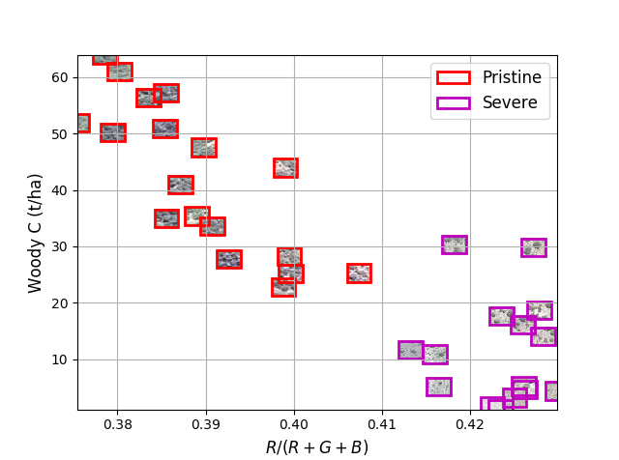

Figure 2 Woody C and normalised red scatter plot

|  |  |  |
| --- | --- | --- |
| **Feature Description** | **Feature Equation** | **Coefficient** |
| Normalised infrared |  | -57.98 |
| NDVI standard deviation |  | 25.12 |
| Intensity |  | -16.46 |
| Infrared ratio |  | 10.77 |

Table 1 Details of LASSO selected features (R, G, B and IR refer to the red, green, blue and infrared channels respectively)

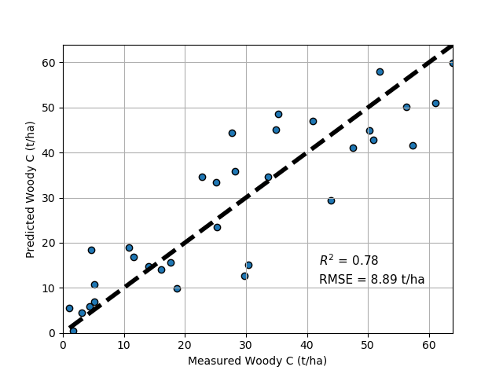

Figure 3 Measured and predicted woody C scatter plot

**APPENDIX 3 (activities 4 & 5):**

Improvements were made to existing radiometric calibration software. The software implements a method for the radiometric homogenisation of high resolution imagery by calibrating with reference satellite data. A spatially varying model that describes the relationship between image sensor measurement and actual surface reflectance is fitted inside a small sliding window. The software was upgraded to add the ability to fit different model types as well as change the size of the sliding window. Experiments were conducted to establish the best model and sliding window size for calibrating NGI aerial imagery (and high resolution imagery in general). An atmospherically corrected SPOT-5 image was used as a surface reflectance reference to compare calibrated NGI images against. Results of this study are reflected in Figure *4*, which shows that the gain and offset model with a one pixel sliding window marginally outperforms the gain only model. This software utility was used to calibrate the NGI aerial imagery for the study in Appendix 2, and will also be used for calibration of the Worldview-3 satellite image, once that has been acquired.

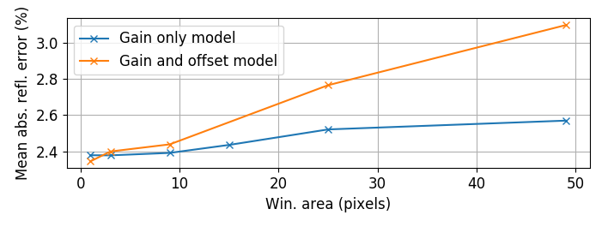

Figure 4 Effect of window size and model on radiometric calibration accuracy